**SMART IRRIGATION SYSTEM**

**ABSTRACT**

Water scarcity is a growing concern in agriculture, and smart irrigation systems have emerged as an efficient solution to address this issue. This project presents a Smart Irrigation System that leverages the NodeMCU microcontroller, a soil moisture sensor, the Blynk platform, and IFTTT integration to optimize water usage in agricultural settings. The system utilizes real-time data from the soil moisture sensor to make informed decisions about when and how much to water the crops.

The NodeMCU, a low-cost and easily programmable Wi-Fi-enabled microcontroller, acts as the central control unit. It collects data from the soil moisture sensor, which is embedded in the soil to measure the moisture level. The data is then transmitted to the Blynk platform, a cloud-based service, via Wi-Fi connectivity. Blynk provides a user-friendly interface that allows farmers and gardeners to monitor and control the irrigation system remotely through a smartphone application. If the moisture content drops below a predefined threshold (e.g., 30%), the system triggers an IFTTT webhook event, which sends a notification to the user's phone. The Shouter app, configured on the phone, reads this message aloud, providing a voice alert that says, "Your plants need to be watered."

The Smart Irrigation System provides a multifaceted solution to enhance irrigation management. It enables real-time monitoring of soil moisture levels, ensures that plants receive optimal water amounts, and offers remote control capabilities. Through continuous data analysis and automated notifications, the system improves water efficiency, reduces operational costs, and keeps users informed. In summary, this integrated system optimizes irrigation practices, conserves resources, and ensures healthy plant growth, while offering hands-free voice alerts for better user convenience.

**TABLE OF CONTENTS**

| **CHAPTER** | **TITLE** | **PAGE NO.** |
| --- | --- | --- |
|  | **INTRODUCTION** |  |
|  | **BLOCK DIAGRAM** |  |
|  | **CIRCUIT DIAGRAM** |  |
|  | **DESCRIPTION OF THE PROJECT** |  |
|  | **TOOLS/HARDWARE BASED APPROACH** |  |
|  | **RESULTS WITH SIMULATION** |  |
|  | **CONCLUSION** |  |
|  | **ANNEXURE** |  |

**1.INTRODUCTION**

**1.1 GENERAL INTRODUCTION**

Agriculture plays a pivotal role in meeting the global demand for food and ensuring the sustainability of ecosystems. However, the increasing stress on water resources, coupled with the need to enhance agricultural efficiency, has prompted the development of innovative solutions. Among these, the Smart Irrigation System has emerged as a transformative approach to agricultural and garden irrigation. This system leverages cutting-edge technologies, such as IoT (Internet of Things), sensors, and cloud computing, to optimize the process of watering plants and crops.

By monitoring and managing water usage in a more intelligent and data-driven manner, smart irrigation systems hold the promise of conserving water, reducing operational costs, and promoting healthier plant growth. In this era of resource conservation and sustainable agriculture, the Smart Irrigation System represents a technological leap forward that addresses the critical challenges of water scarcity, environmental sustainability, and food production.

The core components of a typical smart irrigation system include soil moisture sensors, microcontrollers (NodeMCU), and connectivity to cloud-based platforms like Blynk. Soil moisture sensors are embedded in the ground to measure moisture levels, providing crucial data on whether watering is required. The microcontroller processes this data and triggers the irrigation system when moisture levels fall below a set threshold. Additionally, integration with services like IFTTT and the Shouter app allows for automated voice notifications on the user’s smartphone, enhancing the usability and responsiveness of the system.

**1.2 OBJECTIVE**

The Smart Irrigation System utilizing NodeMCU, Soil Moisture Sensor, Blynk, IFTTT, and Shouter is designed to achieve several key objectives. First and foremost, it focuses on water conservation by meticulously monitoring soil moisture levels and delivering water precisely when needed, thereby reducing water wastage and promoting responsible resource management. Secondly, the system aims to enhance crop and plant health, increasing productivity through its ability to maintain optimal moisture levels.

It contributes to cost reduction by minimizing water and energy expenses, all while affording users the convenience of remote monitoring and control, allowing them to make informed decisions about irrigation processes. Furthermore, the system's data-driven approach ensures that water is supplied efficiently, and users are promptly alerted to any deviations from the desired moisture range through voice notifications via IFTTT and the Shouter app.

By promoting sustainability and responsible water usage, this technology aligns with environmental responsibility and serves as an educational tool for raising awareness about the importance of sustainable farming practices. Its scalability, adaptability, and user-friendly interface make it suitable for applications ranging from residential gardens to large-scale agriculture. It serves as a comprehensive solution for modernizing irrigation processes, aligning them with environmental conservation and efficient resource management practices, while simultaneously improving crop health and reducing operational costs.

**2. BLOCK DIAGRAM**

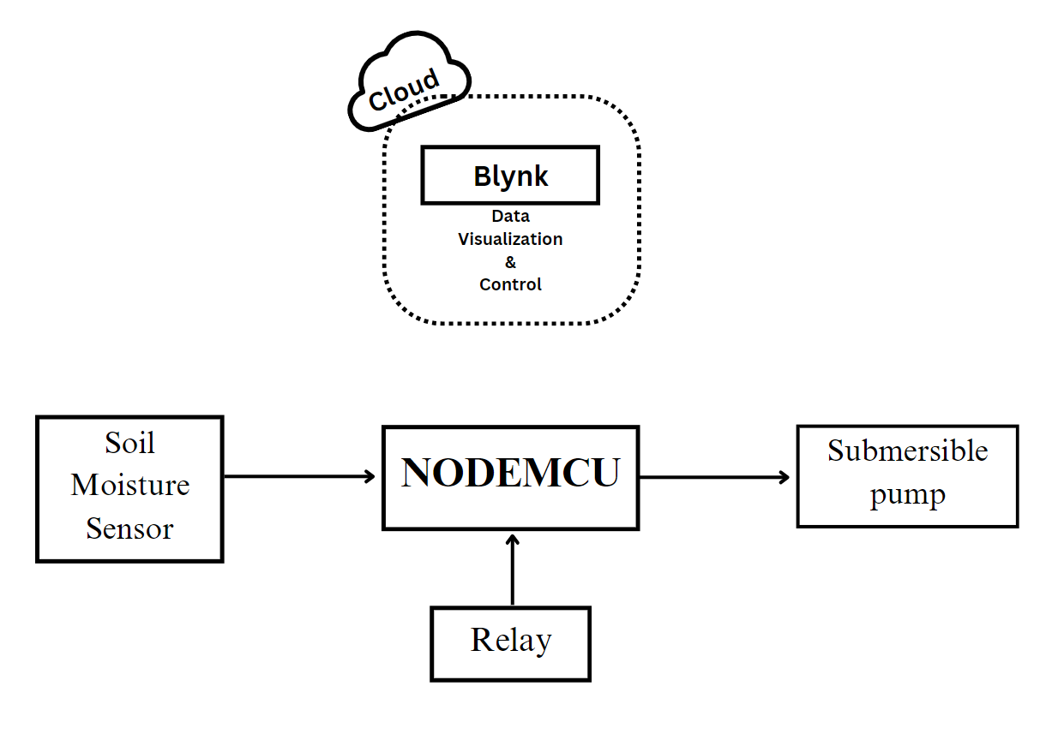

The Smart Irrigation System using NodeMCU, Soil Moisture Sensor, and Blynk operates by continuously measuring soil moisture levels with a sensor embedded in the soil. The NodeMCU microcontroller processes this data and, based on a predefined moisture threshold, triggers the irrigation system when moisture falls below the desired range. Through a connection to the Blynk platform, users can remotely monitor and control the system via a smartphone app, choosing between automatic and manual watering modes. The system's notifications and alerts keep users informed of critical moisture level changes. This seamless integration optimizes water use, conserves resources, and ensures healthier plant growth, making it a valuable tool for both residential gardening and large-scale agriculture.

**3.CIRCUIT DIAGRAM**

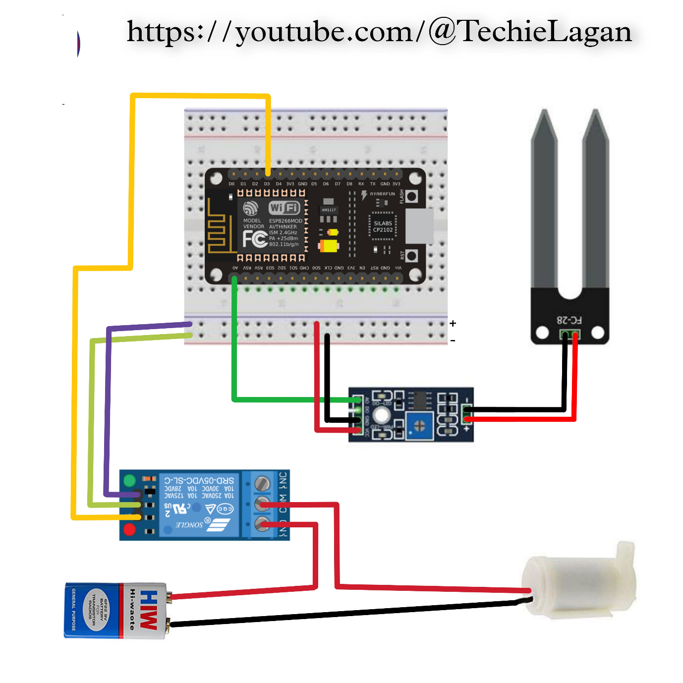

**4. DESCRIPTION OF THE PROJECT**

This project combines cutting-edge technology and environmental sustainability to create an innovative solution for irrigation management. The system revolves around five key components:

**NodeMCU Microcontroller** – Acts as the brain of the system, processing sensor input and controlling the water pump.

**Soil Moisture Sensor** – Embedded in the soil to detect moisture content in real-time.

**Blynk Platform** – A cloud service for IoT device control and monitoring via a smartphone app.

**IFTTT Webhooks** – Triggers an event when soil moisture is below the defined threshold (30%).

**Shouter App** – Reads incoming IFTTT notifications aloud, providing hands-free alerts to the user.

The NodeMCU reads data from the soil moisture sensor and sends the values to Blynk for visualization. If the moisture content drops below 30%, the microcontroller not only activates the water pump (if automation is enabled) but also triggers a webhook to IFTTT. This webhook event causes the IFTTT app to send a notification to the user's phone. With the Shouter app configured to read notifications aloud, the user hears a voice message: “Your plants need to be watered.”

This adds a voice feedback mechanism that ensures users are alerted even without looking at their phones, enhancing responsiveness. The Blynk dashboard allows real-time monitoring, manual override, and historical tracking of soil moisture levels. The system is compact, affordable, and scalable for a variety of applications from home gardening to commercial agricultural use.

**5.TOOLS/HARDWARE-BASED APPROACH**

1. **SOIL MOISTURE SENSOR**

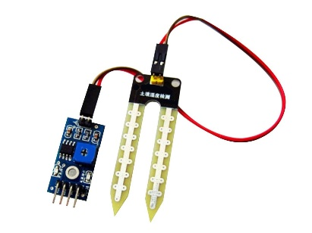

A soil moisture sensor is an electronic device that measures the water content in the soil by assessing its electrical conductivity, with applications spanning agriculture, horticulture, and environmental monitoring. These sensors provide essential data for optimizing irrigation, enhancing plant growth, and conserving water resources, making them invaluable tools for promoting sustainable and efficient land and water management practices, whether in precision agriculture, landscaping, or ecological research.

**2.NODEMCU**

NodeMCU is an open-source, low-cost IoT (Internet of Things) development platform based on the popular ESP8266 microcontroller. It features built-in Wi-Fi connectivity, making it a versatile tool for creating IoT projects and prototypes. NodeMCU supports the Lua scripting language and allows users to easily program and connect devices to the internet, making it a preferred choice for DIY enthusiasts and developers. Its compact size, low power consumption, and affordability have made NodeMCU a popular choice for a wide range of IoT applications, including home automation, smart devices, and sensor monitoring.

**3. RELAY**

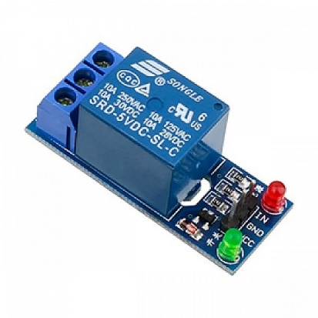

A relay is an electromechanical switch that uses a low-voltage electrical signal to control the operation of a high-voltage or high-current circuit. It plays a crucial role in various applications, including automation, electrical control systems, and safety circuits. Relays are designed to isolate and protect the control circuit from the high-power circuit, enabling remote or automated control of electrical devices and ensuring the safe operation of machinery and equipment by allowing or interrupting electrical current flow in response to specific conditions or signals.

**4. SUBMERSIBLE PUMP**

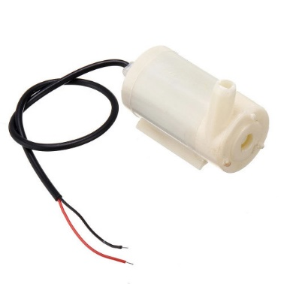

A submersible pump is a type of water pump designed to be fully submerged in liquid, typically water, for applications such as well pumping, drainage, and sewage removal. These pumps are hermetically sealed to prevent water from entering and damaging the motor, and they operate efficiently by pushing water to the surface through a series of impellers. Submersible pumps are commonly used in residential, agricultural, and industrial settings due to their ability to deliver water from deep underground sources and their reliability in continuous operation, making them a vital component for various water management and distribution systems.

**5.2 SOURCE CODE**

#define BLYNK_PRINT Serial

#include <ESP8266WiFi.h>

#include <BlynkSimpleEsp8266.h>

#include <ESP8266HTTPClient.h>

// Blynk credentials

char auth[] = "**********************"; // Your Blynk Auth Token

char ssid[] = "*********"; // Your WiFi SSID

char pass[] = "*********"; // Your WiFi Password

// IFTTT settings

const char* host = "maker.ifttt.com";

String IFTTT_KEY = "your_ifttt_key"; // <-- Replace with your actual IFTTT key

String eventName = "plant_alert"; // This should match your IFTTT event name

bool smsSent = false; // To prevent repeated alerts

BlynkTimer timer;

bool Relay = 0;

// Define component pins

#define sensor A0

#define waterPump D3

void setup() {

Serial.begin(9600);

pinMode(waterPump, OUTPUT);

digitalWrite(waterPump, HIGH); // Pump OFF initially

Blynk.begin(auth, ssid, pass, "blynk.cloud", 80);

// Call the function every 100 ms

timer.setInterval(100L, soilMoistureSensor);

}

// Get the button value from Blynk (V1)

BLYNK_WRITE(V1) {

Relay = param.asInt();

if (Relay == 1) {

digitalWrite(waterPump, LOW); // Turn ON pump

} else {

digitalWrite(waterPump, HIGH); // Turn OFF pump

}

}

// Soil moisture sensor logic

void soilMoistureSensor() {

int value = analogRead(sensor);

value = map(value, 0, 1024, 0, 100);

value = (value - 100) * -1; // Convert to percentage (0 = dry, 100 = wet)

Blynk.virtualWrite(V0, value); // Send to Blynk

// If moisture is low and SMS hasn't been sent yet

if (value < 30 && !smsSent) {

sendIFTTTAlert();

smsSent = true;

}

// Reset flag when soil moisture becomes normal

if (value >= 30) {

smsSent = false;

}

}

// Trigger IFTTT Webhook

void sendIFTTTAlert() {

if (WiFi.status() == WL_CONNECTED) {

HTTPClient http;

String url = "http://" + String(host) + "/trigger/" + eventName + "/with/key/" + IFTTT_KEY;

http.begin(url);

int httpCode = http.GET();

if (httpCode > 0) {

Serial.println("IFTTT Triggered Successfully");

} else {

Serial.println("Error Triggering IFTTT");

}

http.end();

}

}

void loop() {

Blynk.run(); // Run Blynk

timer.run(); // Run Timer

}

**OUTPUT**

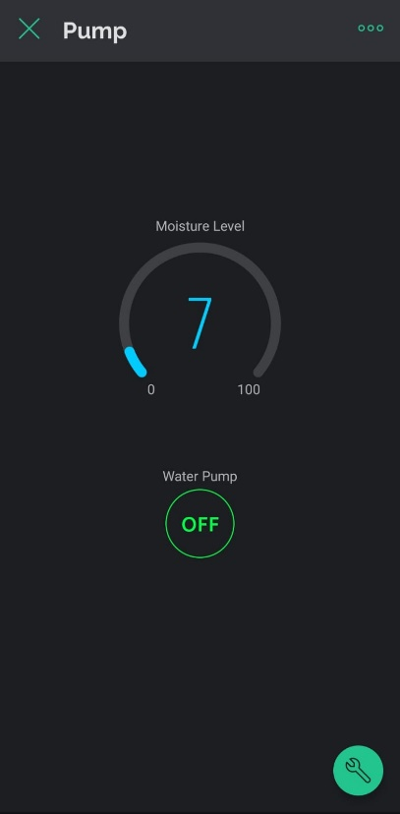1.When the moisture level of the soil is less:

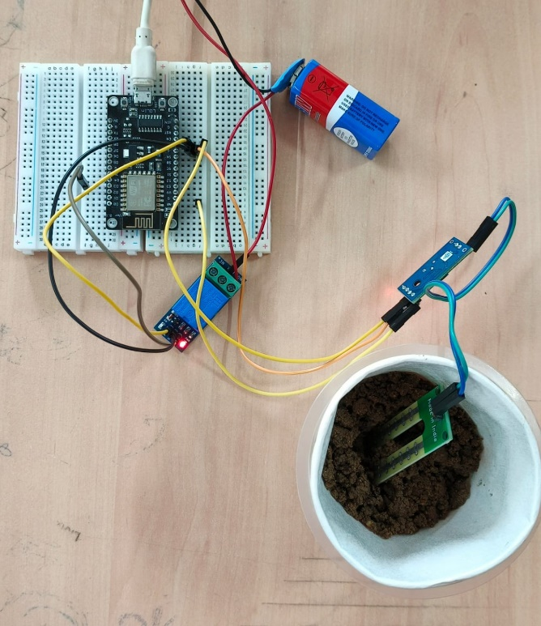

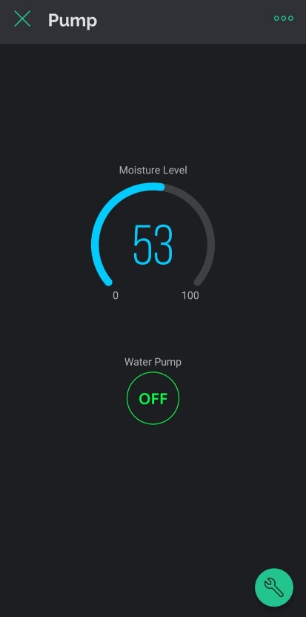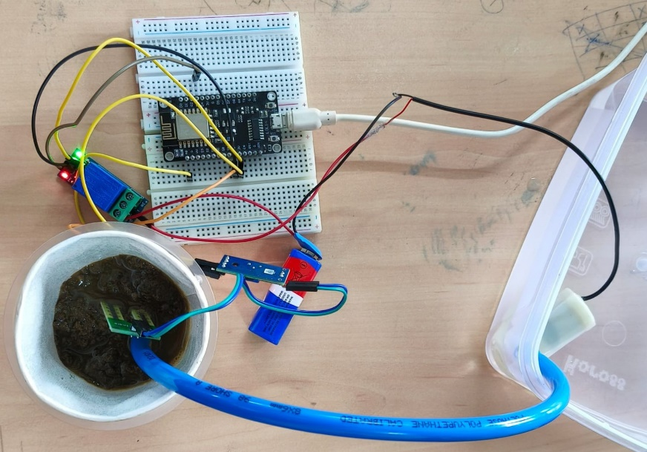2. When the moisture level of the soil is more:

3. Phone interface to monitor moisture level and control submersible pumnp:

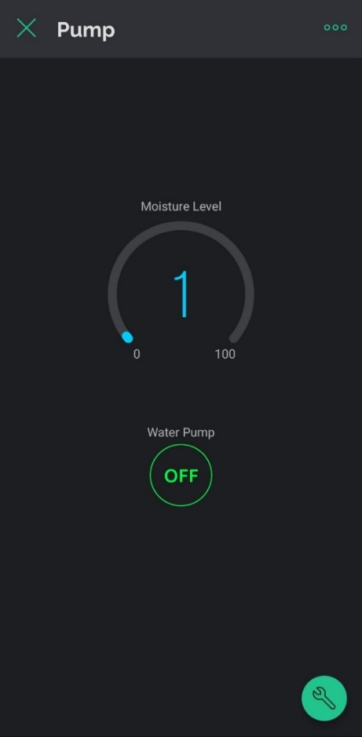

4. SMS Notification Alert:

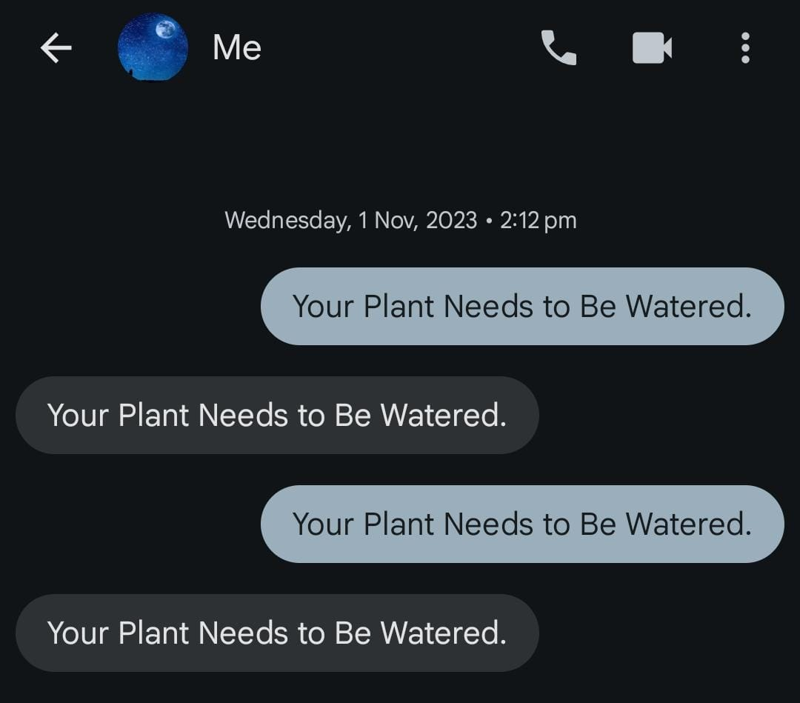

**CONCLUSION**

The Smart Irrigation System utilizing NodeMCU, Soil Moisture Sensor, Blynk, IFTTT, and the Shouter app represents a remarkable integration of technology, sustainability, and efficiency in the realm of irrigation management. This project has the potential to revolutionize the way we approach water resource management in agriculture and horticulture. By harnessing real-time data, it ensures that plants receive the precise amount of water required for healthy growth, effectively mitigating issues like overwatering and water wastage.

Furthermore, this system aligns perfectly with the global shift towards sustainable farming practices, helping to address the pressing concerns of water scarcity and environmental responsibility. Its capacity for remote monitoring and control not only simplifies irrigation management but also fosters an environmentally conscious and economically sustainable approach to agriculture. The inclusion of automated voice alerts through IFTTT and the Shouter app provides a new layer of convenience and immediacy, ensuring that users are informed and responsive in real-time.

As we face increasing challenges related to water conservation and sustainable food production, the Smart Irrigation System stands as a powerful tool that has the potential to reshape the future of agriculture and gardening practices. In summary, this innovative irrigation system offers a glimpse into the promising future of precision agriculture and resource-efficient landscaping. By promoting water conservation, enhancing crop health, and providing user-friendly remote and audible management, it epitomizes the intelligent, data-driven solutions needed to address the ever-growing demands of a changing world. This system demonstrates the strength of combining hardware, cloud services, and mobile apps into a unified, automated solution

**ANNEXURE**

* <https://srituhobby.com/smart-irrigation-system-using-nodemcu-and-blynk/>
* <https://www.instructables.com/IoT-Based-Smart-Irrigation-System-Using-NodeMCU-ES/>
* <https://www.youtube.com/watch?v=r13VFOAHheA>